Experiment Number: 1
Simulation and Comparative Analysis of FDMA, TDMA and CDMA
Objective 1:
clear; clc; close all;

% Illustrative system parameters
totalBandwidthHz = 1e6; % Total bandwidth: 1 MHz
fdmaChannelHz = 200e3; % FDMA channel width: 200 kHz
tdmaSlots = 8; % Number of TDMA slots per frame
processingGain = 64; % CDMA processing gain
targetSIRdB = 7; % Minimum acceptable CDMA SIR

% Capacity estimates
fdmaUsers = floor(totalBandwidthHz / fdmaChannelHz);
tdmaUsers = tdmaSlots;

targetSIR = 10^(targetSIRdB / 10);
cdmaUsers = floor(1 + processingGain / targetSIR);

fprintf('Illustrative maximum supported users\n');
fprintf('FDMA: %d users\n', fdmaUsers);
fprintf('TDMA: %d users\n', tdmaUsers);
fprintf('CDMA: %d users at a target SIR of %.1f dB\n\n', ...
cdmaUsers, targetSIRdB);

% CDMA SIR as the number of simultaneous users increases
K = 2:30;
sirLinear = processingGain ./ (K - 1);
sirDb = 10 * log10(sirLinear);

% Display comparison table
method = ["FDMA"; "TDMA"; "CDMA"];
supportedUsers = [fdmaUsers; tdmaUsers; cdmaUsers];
results = table(method, supportedUsers);
disp(results);
% Plot estimated user capacity
figure;
bar(categorical(method), supportedUsers);
ylabel('Illustrative maximum supported simultaneous users');
title('FDMA, TDMA and CDMA: Capacity Estimate');
grid on;
% Plot estimated CDMA SIR versus number of users
figure;
plot(K, sirDb, 'o-', 'LineWidth', 1.5);
hold on;
yline(targetSIRdB, '--r', 'Target SIR');
xlabel('Number of simultaneous CDMA users (K)');
ylabel('Estimated SIR (dB)');
title('Estimated CDMA SIR versus Number of Users');
grid on;
hold off;
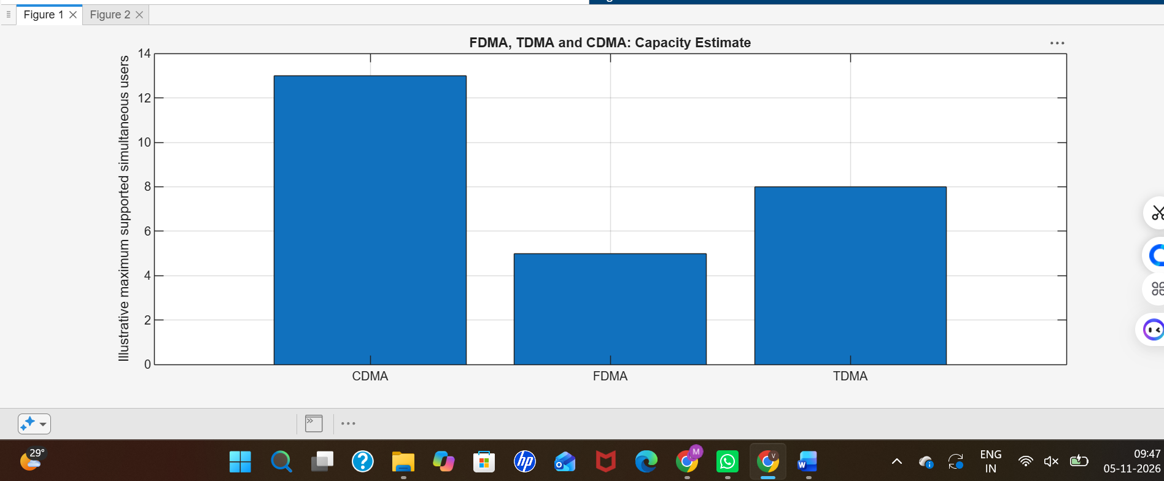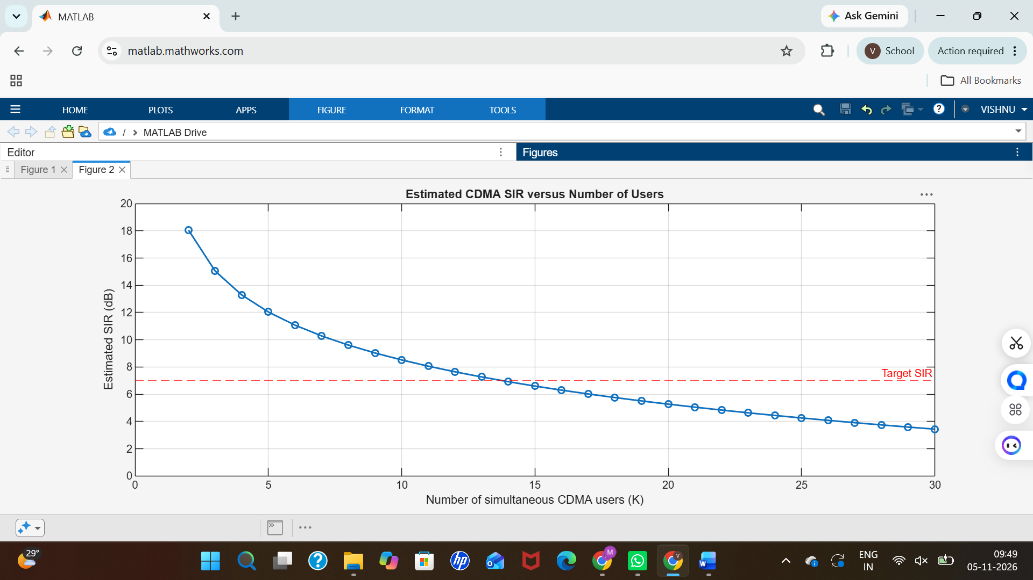

Objective 3:
generation = ["1G"; "2G"; "2G"; "3G"; "4G"; "5G"]; system = ["AMPS"; "GSM"; "IS-95"; "UMTS"; "LTE"; "5G NR"];
accessMethod = ["FDMA"; "TDMA"; "CDMA"; "WCDMA"; "OFDMA"; "OFDMA-based"]; keyIdea = ["Separate frequency channels"; ...
"Separate time slots"; ...
"Code-based user separation"; ...
"Wideband code-based access"; ...
"Orthogonal frequency resources"; ...
"Flexible OFDM-based radio access"];

evolutionTable = table(generation, system, accessMethod, keyIdea); disp(evolutionTable);
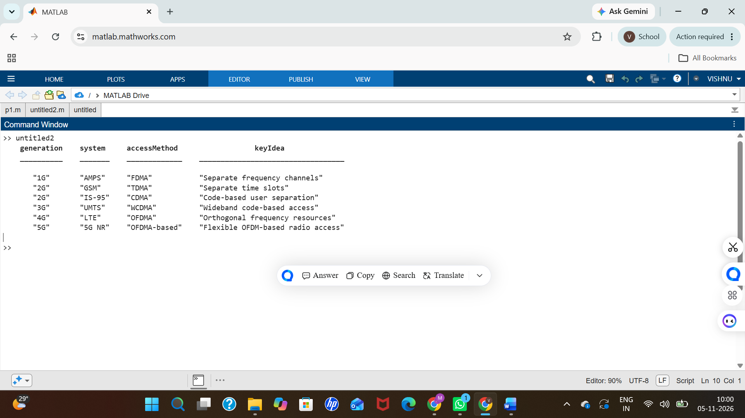
Objective 4: Resource-allocation diagrams

clear; clc; close all;
figure;
tiledlayout(1,3);
colors = lines(4);
% FDMA: Users occupy different frequency channels
nexttile;
hold on;
for u = 1:4
rectangle('Position',[0, u-1, 1, 0.8], ...
'FaceColor',colors(u,:), 'EdgeColor','k');
text(0.5, u-0.6, sprintf('User %d',u), ...
'HorizontalAlignment','center');
end
xlim([0 1]);
ylim([0 4]);
xlabel('Time');
ylabel('Frequency channel');
title('FDMA');
set(gca,'YTick',[]);
hold off;
% TDMA: Users occupy different time slots
nexttile;
hold on;
for u = 1:4
rectangle('Position',[u-1, 0, 0.8, 1], ...
'FaceColor',colors(u,:), 'EdgeColor','k');
text(u-0.6, 0.5, sprintf('User %d',u), ...
'HorizontalAlignment','center');
end
xlim([0 4]);
ylim([0 1]);
xlabel('Time slot');
ylabel('Frequency channel');
title('TDMA');
set(gca,'YTick',[]);
hold off;
% CDMA: Users share time and frequency using different codes
nexttile;
hold on;
for u = 1:4
rectangle('Position',[0, 0, 1, 1], ...
'FaceColor',colors(u,:), ...
'FaceAlpha',0.22, ...
'EdgeColor',colors(u,:), ...
'LineWidth',1.5);
end
text(0.5, 0.62, 'Users 1-4 share', ...
'HorizontalAlignment','center');
text(0.5, 0.40, 'band; different codes', ...
'HorizontalAlignment','center');
xlim([0 1]);
ylim([0 1]);
xlabel('Time');
ylabel('Frequency band');
title('CDMA');
set(gca,'YTick',[]);
hold off;
sgtitle('Conceptual Time-Frequency Resource Allocation');


